Bahria University,

Karachi Campus



LAB EXPERIMENT NO. _07_

LIST OF TASKS

|  |  |
| --- | --- |
| TASK NO | OBJECTIVE |
| Task 1 | Find the length of the string (the String should be inserted by the user). |
| Task 2 | Take 2 strings as an input and concatenate them. |
| Task 3 | Write a C++ that contain two strings:  String1= “A **line** is the path of one point moving.”.  String2 = “line is a type of geometric figure”  perform following functions on these strings:   * 1. strfind( ) on String1.// line   2. Substr()on string 1 // point moving   3. strlen() on String1 and String2   4. insert() “ Despicable me!!” in String2   5. remove() “type” from String2   6. replace() “moving” from String1 and insert “ Despicable me!!” in String1.   7. Copy () “line is the path” from String 1 to String2. |
| Task 4 | Take a loop which will read characters from cin until the user signals the end of data input (<Ctrl>-z in Windows) and count the number of characters read in. It also sends a copy of each character to cout. |
| Task 5 | Get a character ch from user and returns true if ch is a lowercase alphabetic character or false if it is not. (hint: islower() ) |
| Task 6 | N/A |
| Task 7 | N/A |
| Task 8 | N/A |

Submitted On:

__14/05/2020__

(Date: DD/MM

**Task No. 1:** Find the length of the string (the String should be inserted by the user).

**Coding:**

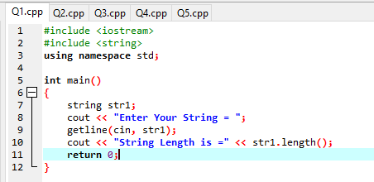

**Output:**

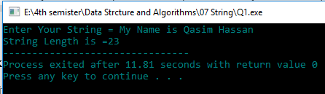

**Task No. 2:** Take 2 strings as an input and concatenate them.

**Coding:**

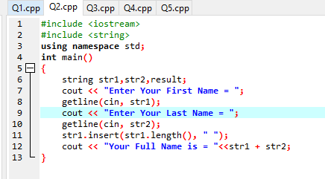

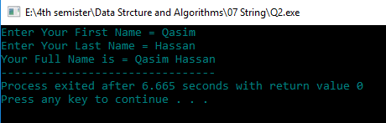**Output:**

**Task No. 3:**

Write a C++ that contain two strings:

String1= “A **line** is the path of one point moving.”.

String2 = “line is a type of geometric figure”

perform following functions on these strings:

1. strfind( ) on String1.// line
2. Substr()on string 1 // point moving
3. strlen() on String1 and String2
4. insert() “ Despicable me!!” in String2
5. remove() “type” from String2
6. replace() “moving” from String1 and insert “ Despicable me!!” in String1.

Copy () “line is the path” from String 1 to String2.

**Coding:**

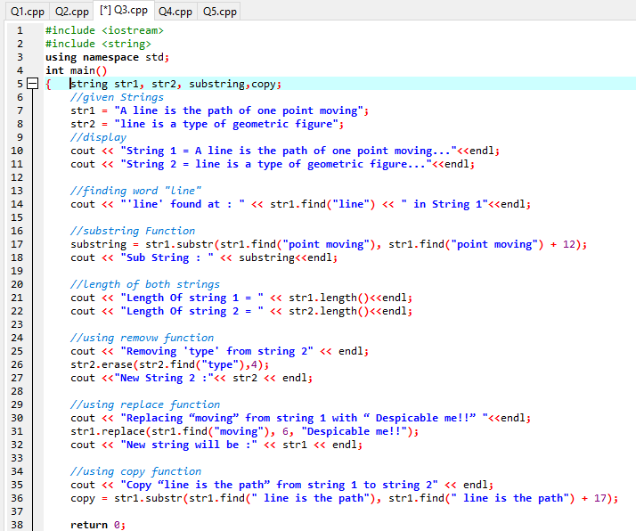



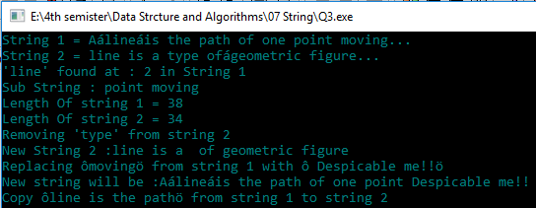**Output:**

**Task No. 4:** Take a loop which will read characters from cin until the user signals the end of data input (<Ctrl>-z in Windows) and count the number of characters read in. It also sends a copy of each character to cout.

**Coding:** 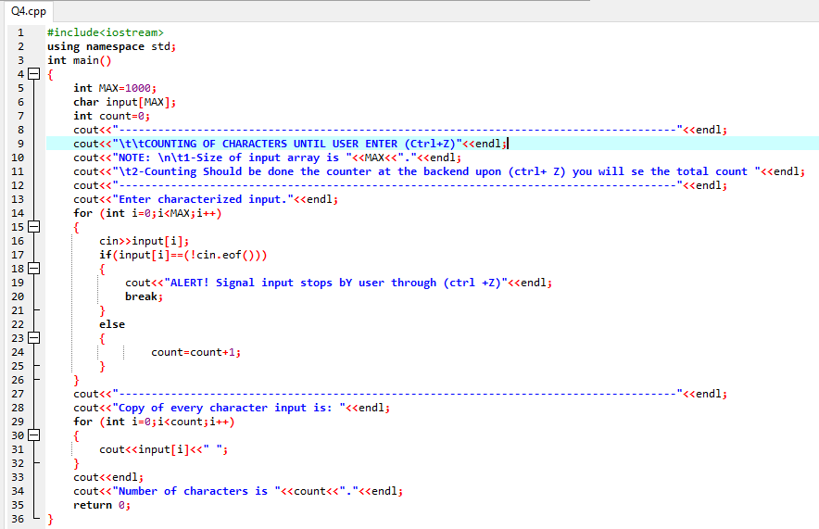

**Output:**

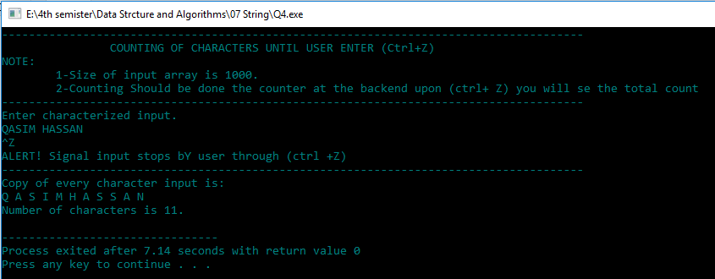

**Task No: 05** Get a character ch from user and returns true if ch is a lowercase alphabetic character or false if it is not.(hint : islower() )

**Function Checks**

* isalpha() is the parameter alphabetic ('A'..'Z' or 'a'..'z')
* isdigit() is the parameter a digit (0..9)
* isalnum() is the parameter alphabetic or a digit
* isspace() is the parameter a space (' ')
* ispunct() is the parameter a piece of punctuation
* islower() is the parameter a lowercase alphabetic character ('a'..'z')
* isupper() is the parameter an uppercase alphabetic character ('A'..'Z')

**Coding:**

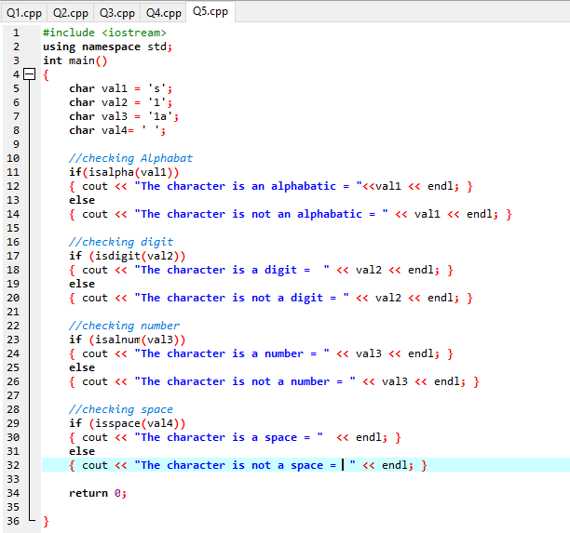



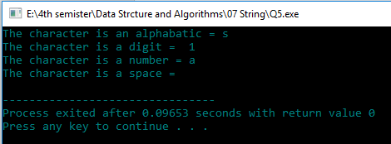**Output:**